Crowd Fire Evacuation Simulation

By Hnin Mon and David Oganov

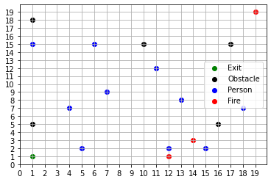This simulation, developed in Python 3 using the Spyder Integrated Development Environment (IDE), is an agent-based model designed to simulate the dynamics of fire propagation and crowd evacuation in various scenarios. By incorporating real-time crowd behavior such as panic, this simulation provides valuable insights into emergency evacuation strategies and helps answer critical questions related to safety, evacuation time, and optimal resource allocation. The simulation code can be found on our [GitHub](https://github.com/davidoganov/Crowd-Simulation) repository.

**User’s Manual**

# Installing the program:

* Check to ensure that Python 3 is installed.
* Download the zip files from the GitHub repository linked at the top of the document.
* Unzip the files into a new folder.
* Open the newly created folder on a Python IDE. (Preferably [Spyder](https://www.spyder-ide.org/) to avoid errors with plots)

# Overview of the files:

* Main.py
  + This file is the main driver for the simulation. It makes the calls to simulation, instantiating an environment, and agents.
* Agents.py
  + This file is the basic building block that would simulate the behavior and the interaction of people and fire within the building (environment). It has two subclasses: Person and Fire. The Person class represents people in the building trying to escape fire. The Fire class represents fire instances within the building.
* Environment.py
  + This file is responsible for defining and managing the environment for simulation. It also takes care of the method for plotting the current state of the environment for visualization.
* Simulation.py
  + This file is the core driver of the entire simulation process. It manages the environment setup, agent behaviors and time progression while also tracking the overall progress and outcomes.

# Running the program:

* In your Python IDE with your folder containing the program open, select main.py.
* A readily runnable variation of the simulation is currently in place but alterations to used values in the simulation to the following may be made if necessary:
  + Simulation environment size [(*int) x (int)*]
  + The number of people in the simulation [int]
  + The number of fires in the room [int]
  + The number of obstacles in the room [int]
  + The exit positions in the room [tuple]
  + The number of simulation iterations to be made [int]
  + The time step to be used in the simulation [int]
* There are various functions available for use to provide information for various analysis questions.
  + Plotting the projected number of persons to escape the room versus the actual number
    - ***plot_proj_num_escaped_vs_actual***
  + Plotting the number of persons to escape the room over the specified time
    - ***calculate_and_plot_num_escaped_over_time***
  + Plotting the average and standard deviation of escape counts with varying exit positions
    - ***calculate_and_plot_exit_variation***
  + Plotting the number of dead persons over the specified time
    - ***calculate_and_plot_dead_over_time***
  + Plotting the number of bottlenecks vs. The number of persons in the simulation
    - ***calculate_bottleneck_areas***
    - ***plot_bottleneck_areas***
  + Plotting the average number of escaped persons over various grid sizes
    - ***plot_various_grid_sims***
* There exists a function in the file that is meant to perform the simulation. This function takes in an instance of a simulation and a time step to follow to step through it and plot the environment at each time step.
  + ***run_simulation(simulation, timeStep)***
* Plots rendered using this source code will render in Spyder’s Plot pane.

**Analysis Report**

***How does the crowd behave under different environment layouts?***

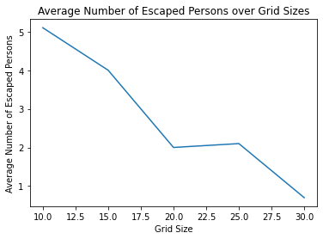The behavior that we observed in the simulations indicates that as the size of the grid (both height and width) increases, the average number of people escaping the room decreases. This correlation can be explained by the fact that as the grid size begins to expand, the distance that the escapees must traverse to reach a viable exit becomes larger. Consequently, it becomes more challenging for individuals to escape within the given time frame, resulting in a lower average.

**Figure 1.2: Average Number of Escaped Persons over Grid Sizes**

The behavior that we observed in the simulations indicates that as the size of the grid (both height and width) increases, the average number of people escaping the room decreases. This correlation can be explained by the fact that as the grid size begins to expand, the distance that the escapees must traverse to reach a viable exit becomes larger. Consequently, it becomes more challenging for individuals to escape within the given time frame, resulting in a lower average. The figure above runs the simulation 10 times over each grid size [(10 x 10), (15 x 15), (20 x 20), (25 x 25), (30 x 30)]. The number of people in each simulation iteration is a constant 10 people, in this case.

To mitigate this issue, one potential feasible solution we found was to increase the number of exits in proportion to the size of the environment. The introduction of more exit points resulted in a higher probability that the people would reach the exit points before the provided time frame was completed.

Figure 1.2 may be compared to Figure 1.3 below, where Figure 1.3 depicts the projected number of people to escape the building within the time frame versus the actual number of people who escaped in 10 simulations with a constant grid size of (20 x 20), ten people, three fires, and five obstacles.

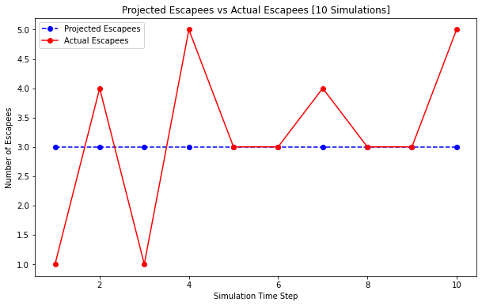

**Figure 1.3: Projected Escapees vs Actual Escapees**

The Washington State Legislature requires employers to ensure that the workplace meets several different requirements, including "two exit routes, remote from one another, are available to provide alternate means for employees to safely leave the workplace during an emergency." We created simulations with minimum layout sizing options for our simulations. As a result, we ended up with two exit positions that were (indirectly) opposite each other. Despite the presence of these escape options, the crowd's conduct remained consistent with a "follow the herd" approach.

***What are the critical bottlenecks in the crowd flow, and how do they affect evacuation time?***

Critical bottlenecks in the crowd flow indicate that as the density of individuals (the number of people) increases, the slower the movement, resulting in congestion. This occurs when the number of individuals exceeds the capacity of the area (grid), drastically impacting the evacuation time as bottlenecks hinder people as they move toward safety exits. They can eventually lead to crowd panic, escalating the situation even further. Therefore, identifying and managing these bottlenecks is essential to ensuring effective, efficient, and safe evacuation processes.

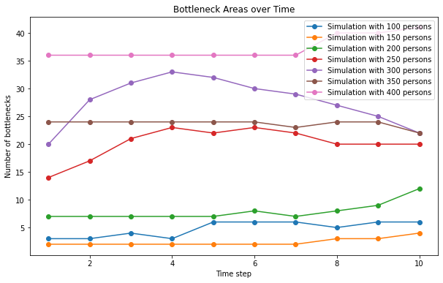

**Figure 1.4: Bottleneck Areas Over Time**

Based on the above simulated output, the number of bottlenecks increases as the number of people in the simulation increases. This suggests that larger crowds experience a higher frequency of bottleneck formation. Bottlenecks hinder the smooth flow of individuals towards exits, causing congestion and delays. With more bottlenecks, the movement of people becomes slower and more challenging, therefore, increasing evacuation times.

In simulations 1 and 2, the number of bottlenecks is relatively small (6 and 4, respectively), indicating the impact on evacuation time is manageable. However, in simulations 3,4,5 and 6, with a higher number of bottlenecks (ranging from 12 to 22), evacuation times are likely to be greatly affected. Finally, the presence of 41 bottlenecks in simulation 7 indicates a highly congested environment, which can cause sever delay and create safety risk.

These results emphasize the importance of managing bottlenecks to improve evacuation efficiency. Different strategies like optimizing exit routes, increasing the number of exits, or implementing crowd management techniques can help mitigate the impact of bottlenecks and ensure smoother and safer evacuations.

***How do different crowd management strategies, such as exit routes or crowd reaction, impact crowd behavior and safety?***

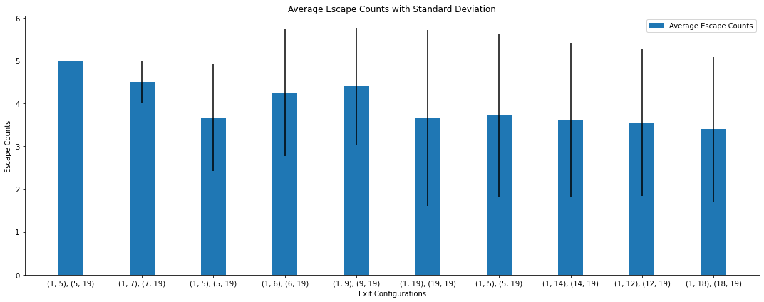**Figure 1.5: Average Escape Counts with Standard Deviations**

The figure above represents the average escape counts with varying exit points in the grid. It takes in a constant ten people, grid size of 20 x 20, three fires, five obstacles, and two exit points that vary along the edges of the environment.

According to Shiftlet & Shiftlet, “A small standard deviation relative to the mean indicates a certain consistency for most of the simulations and gives us more confidence in the mean as an estimate of the area.” The error bars (represented by vertical lines or caps) on each bar indicate the standard deviation associated with the escape counts. The standard deviation quantifies the variability or spread of escape counts for a given exit configuration. A higher standard deviation suggests that the number of people who managed to evacuate varies more. A lower standard deviation indicates that the consequences of the escape are more consistent or predictable.

The height of each bar in the figure above shows the average number of escapes for a given exit configuration. The average escape count represents the average number of people who successfully departed the environment in that configuration. It provides an overall assessment of the exit configuration's effectiveness in permitting successful escapes. A higher average number of escapes indicates more successful evacuations.

Implementing varying crowd management strategies can significantly influence the safety and behavior of the crowd, impacting their ability to evacuate effectively. As the size of the crowd increases, bottlenecks become more frequent, hindering smooth evacuation, which leads to long escape times. Therefore, designing exit routes is critical: evenly distributed and easily accessible exits (ones at opposite ends) help prevent overcrowding at any single exit and reduce bottleneck formation. Also, individual behaviors, represented by varying panic levels, profoundly affect the crowd dynamics.

As the panic levels rise, individuals tend to follow the crowd behaviors, shifting individualistic behavior to herd-like ones. Moreover, the presence of obstacles and fires dynamically alters the environment, requiring adaptable evacuation strategies. Therefore, understanding and implementing effective crowd evacuation is vital for maintaining safety and ensuring efficient evacuations.

Optimizing exit distribution by experimenting with different exit placements or adding more exits can help reduce bottleneck formation and improve crowd distribution. Introducing a guidance system that provides information on the least congested paths or nearest exits can aid individuals (people agents) in making better decisions. Managing panic levels through calming mechanisms, such as authoritative figures or emergency announcements, can reduce overall panic and discourage herd-like behavior.

***What are the critical factors that lead to the success or failure of an evacuation process, and how can they be addressed?***

Several factors strongly influence the success or failure of the evacuation in our simulation of the procedure. The position and number of exits have been observed to play a critical influence in this regard, as illustrated in Figures 1.2 and 1.5. The presence of exits is critical for allowing individuals to safely escape the area.

When the number of exits is increased, the number of escapees increases proportionally. This association is intuitively understandable because individuals have more options when choosing an escape route. With more exits available, people are more likely to discover a nearby exit and successfully escape. This result is consistent with the idea that having numerous evacuation routes improves the efficiency and effectiveness of the evacuation procedure.

When examining the impact of exits on the number of escapees, it is crucial to keep the size of the environment in mind. Even when many exits are provided, the number of escapees tends to drop in larger rooms or surroundings. This tendency can be explained by the extra lengths people must travel to reach the exits. The time and effort required for individuals to walk longer distances to evacuate in larger rooms can limit the number of escapees. As a result, while several exits provide options, the room's size can impose physical limits on the evacuation procedure.

It is critical to find a balance between the number of exits and the size of the environment in order to maximize the evacuation procedure. Having many exits in smaller rooms can dramatically boost the chances of a successful evacuation. In bigger venues, however, extra steps such as optimizing exit placement, providing visible signage, and employing effective crowd control tactics may be required to ensure rapid evacuation.

Our simulation sheds light on the complicated dynamics of the evacuation process by investigating the interplay between the number of exits, the size of the room, and the resulting number of escapees. These insights can help decision-makers create safer surroundings and evacuation strategies that take into consideration the specific qualities and restrictions of the given space.

***Other Highlight Finding:***

Another noteworthy discovery was that people "followed the herd" during the evacuation. People frequently gravitated towards a common exit where others were heading rather than the closest exit. This is due to a dependence on social cues and the sense that the chosen approach is safer or more efficient based on the activities of others. Understanding and accounting for herding behavior in emergency response planning is critical for optimizing evacuation processes and reducing potential congestion near popular exits. Clear signage, information dissemination regarding alternate exits, and crowd management measures can help steer people to less crowded or underutilized exits, improving evacuation efficiency.

**Allocation of Group Contributions**

Hnin Mon – 50% for both milestone & final product

David Oganov – 50% for both milestone & final product

**Bibliography**

*Chapter 10 MEANS OF EGRESS*. (n.d.).

*Fire Death and Injury Risk*. (2022, September 21). U.S. Fire Administration. https://www.usfa.fema.gov/statistics/deaths-injuries/

Kinateder, M., & Warren, W. H. (2016). Social Influence on Evacuation Behavior in Real and Virtual Environments. *Frontiers in Robotics and AI*, *3*. https://www.frontiersin.org/articles/10.3389/frobt.2016.00043

Mohammadiounotikandi, A., Fakhruldeen, H. F., Meqdad, M. N., Ibrahim, B. F., Jafari Navimipour, N., & Unal, M. (2023). A Fire Evacuation and Control System in Smart Buildings Based on the Internet of Things and a Hybrid Intelligent Algorithm. *Fire*, *6*(4), Article 4. https://doi.org/10.3390/fire6040171

OSHA. (n.d.). *Fire Service Features of Buildings and Fire Protection Systems*. chrome-extension://efaidnbmnnnibpcajpcglclefindmkaj/https://www.osha.gov/sites/default/files/publications/OSHA3256.pdf

Purser, D. A., & Bensilum, M. (2001). Quantification of behaviour for engineering design standards and escape time calculations. *Safety Science*, *38*(2), 157–182. https://doi.org/10.1016/S0925-7535(00)00066-7

*Residential Fire Estimate Summaries*. (2022, April 28). U.S. Fire Administration. https://www.usfa.fema.gov/statistics/residential-fires/

Security, H. (2019). *Planning Considerations: Evacuation and Shelter-in-Place Guidance for State, Local, Tribal, and Territorial Partners*. chrome-extension://efaidnbmnnnibpcajpcglclefindmkaj/https://www.fema.gov/sites/default/files/2020-07/planning-considerations-evacuation-and-shelter-in-place.pdf

Shiftlet, A., & Shiftlet, G. (n.d.). *Introduction To Computational Science* (2nd ed.).

*Spyder*. (n.d.). https://www.spyder-ide.org/

*State Fire Loss and Fire Department Profiles*. (2022, January 5). U.S. Fire Administration. https://www.usfa.fema.gov/statistics/states/

*Statistics*. (2023, April 28). U.S. Fire Administration. https://www.usfa.fema.gov/statistics/data-sets/

*WAC 296-307-35009:* (n.d.). Retrieved May 30, 2023, from https://app.leg.wa.gov/wac/default.aspx?cite=296-307-35009

Zheng, H., Zhang, S., Zhu, J., Zhu, Z., & Fang, X. (2022). Evacuation in Buildings Based on BIM: Taking a Fire in a University Library as an Example. *International Journal of Environmental Research and Public Health*, *19*(23), 16254. https://doi.org/10.3390/ijerph192316254